

**“NATIONAL UNIVERSITY OF SCIENCE AND TECHNOLOGY”**

Assignment Submission of ICT

“Configuring Mouse Button Actions”

Jkasdfsdhjf sdakbjjf badskjcasdj csdajhf ncdsnmf csda

Fadsm ggkj asdffldsnf ADS”f adsn fasdfads

axbbv

Submitted to:

Ma’am Zunera Zahid

Submitted by:

Saif Ullah Bin Khaki (268468)

BSCS-8-C

**“Customizing Mouse Button Actions”**

You are required to follow the following steps to achieve your goal:

* First of all chose a third party software for your purpose, it could be any like Hydra Mouse, clicky mouse etc.
* I suggest HYDRA MOUSE. So, download the desired software from the following [link](https://files.downloadnow.com/s/software/12/31/50/11/HMsetup.exe?token=1541357968_0dcb4b929d780e3709dc104a07e5039e&fileName=HMsetup.exe) in your desired location.
* Hence, the downloading will start.

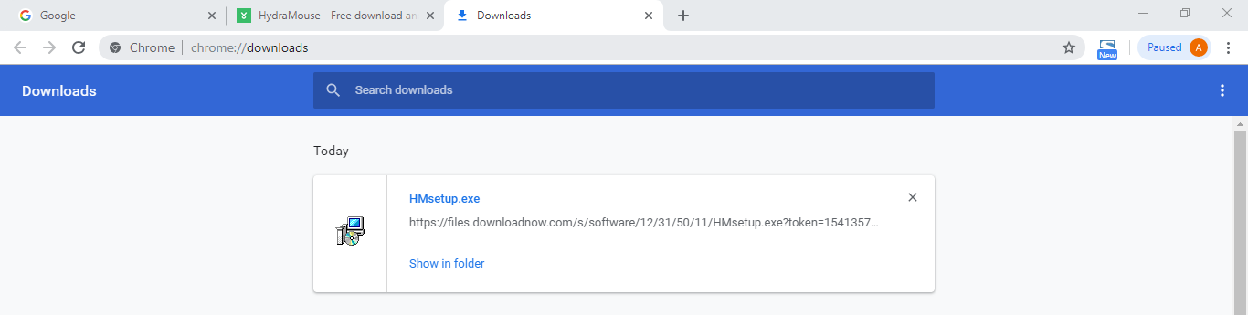

* Now, after downloading, install the software.

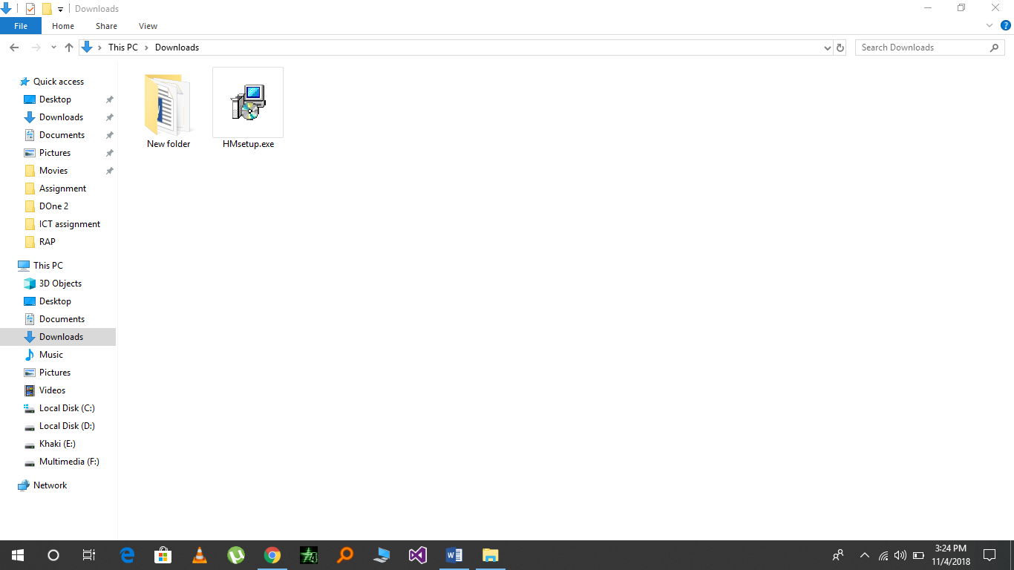

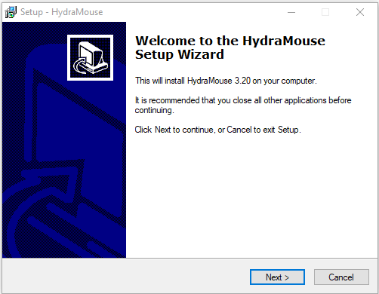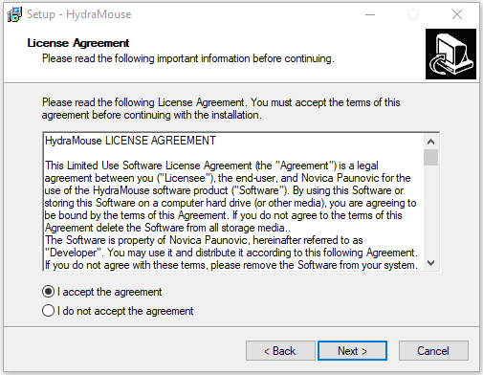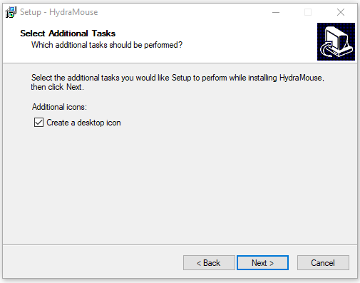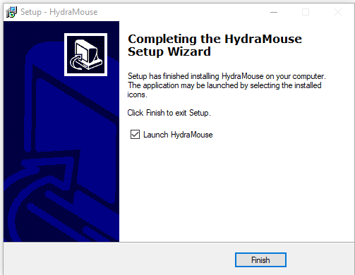

* After installation, Launch **HYDRA MOUSE.** A window will appear.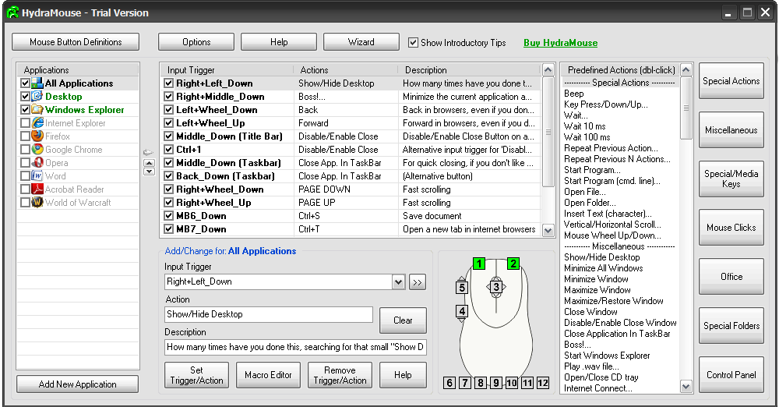

**“MAXIMIZE WINDOW”**

* In the **INPUT TRIGGER,** click middle mouse button. Similarly, in **ACTION,** select **MAXIMIZE** from **PREDEFINED ACTIONS.**

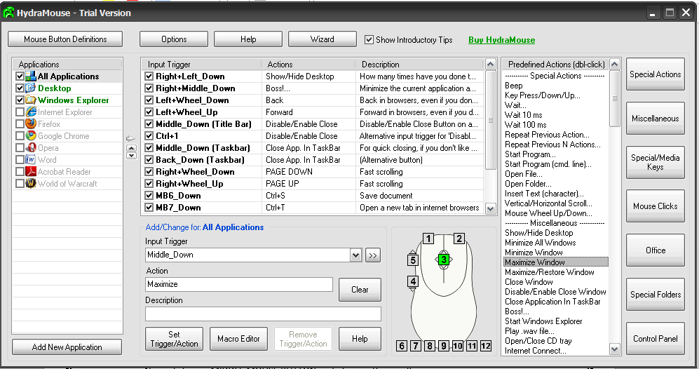

* Then press **SET TRIGGER/ACTION.**

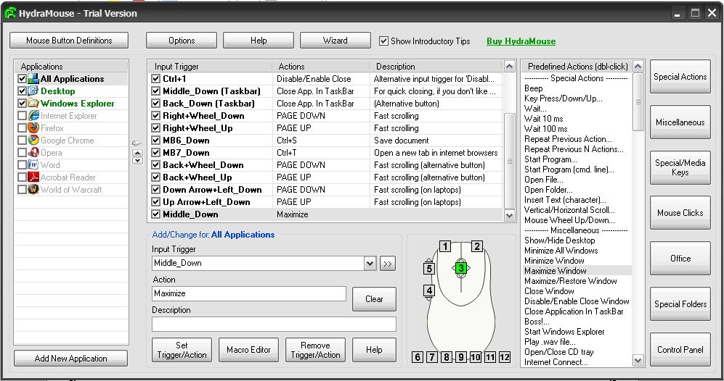

* Now take a benchmark, open any file, and minimize it first.

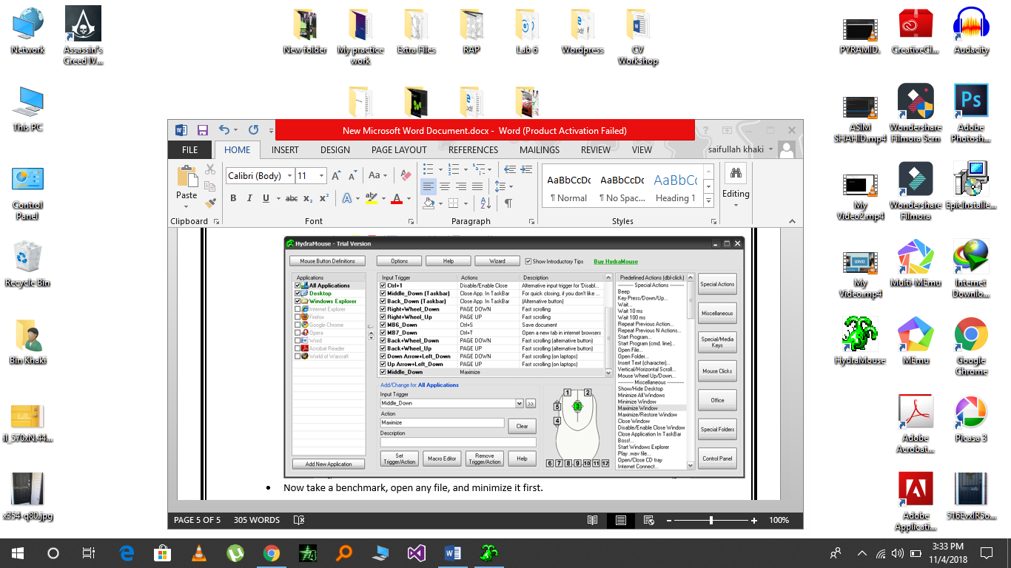

* Now, click your MIDDLE MOUSE BUTTON and observe the result.

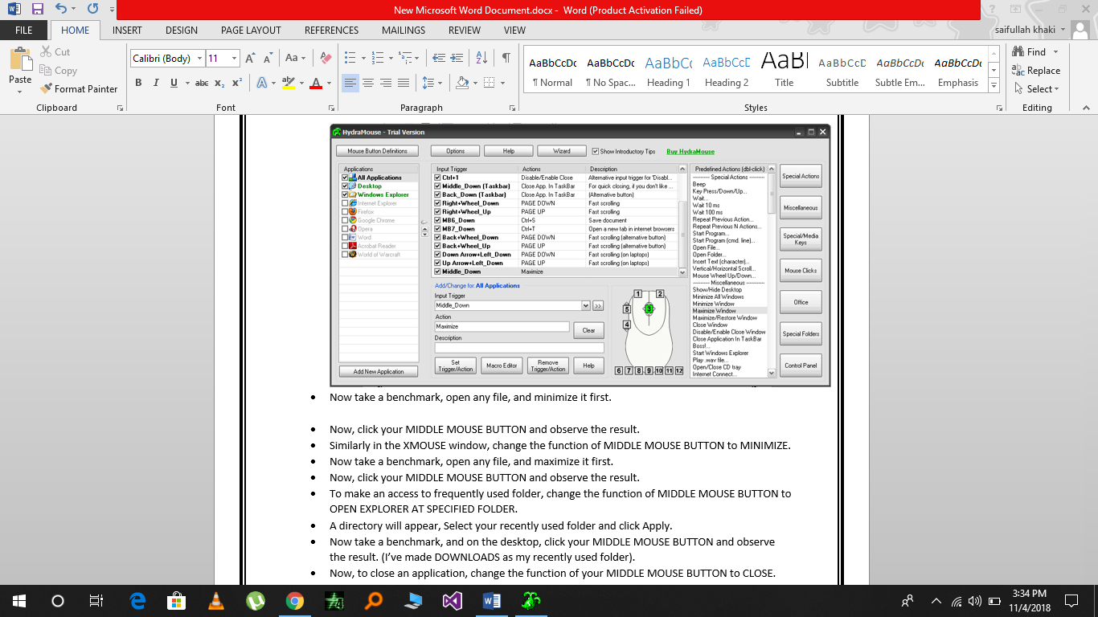

**“MINIMIZE WINDOW”**

* Similarly in the **HYDRA MOUSE** window, first remove the **FORMER TRIGGER**.

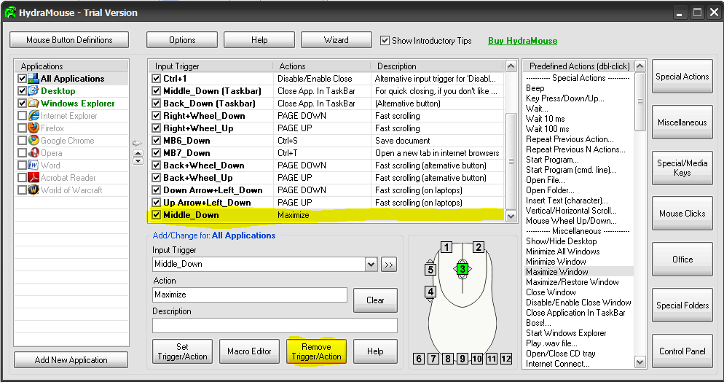

* Change the function of MIDDLE MOUSE BUTTON to **MINIMIZE**.

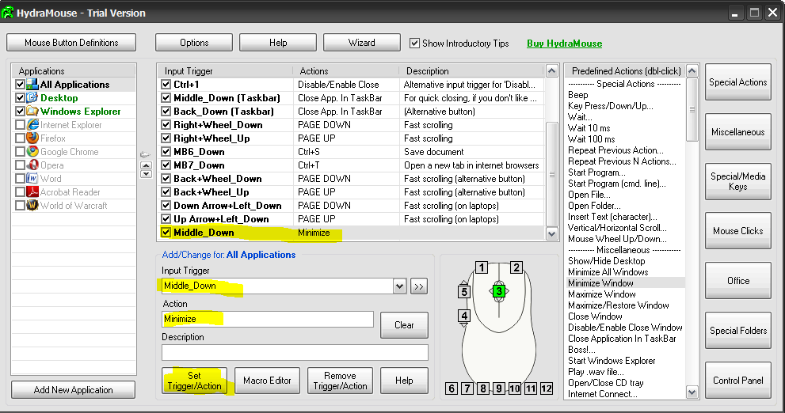

* Now take a benchmark, open any file, and maximize it first.

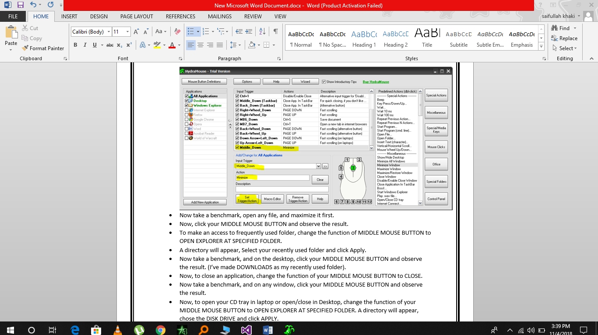

* Now, click your **MIDDLE MOUSE BUTTON** and observe the result.

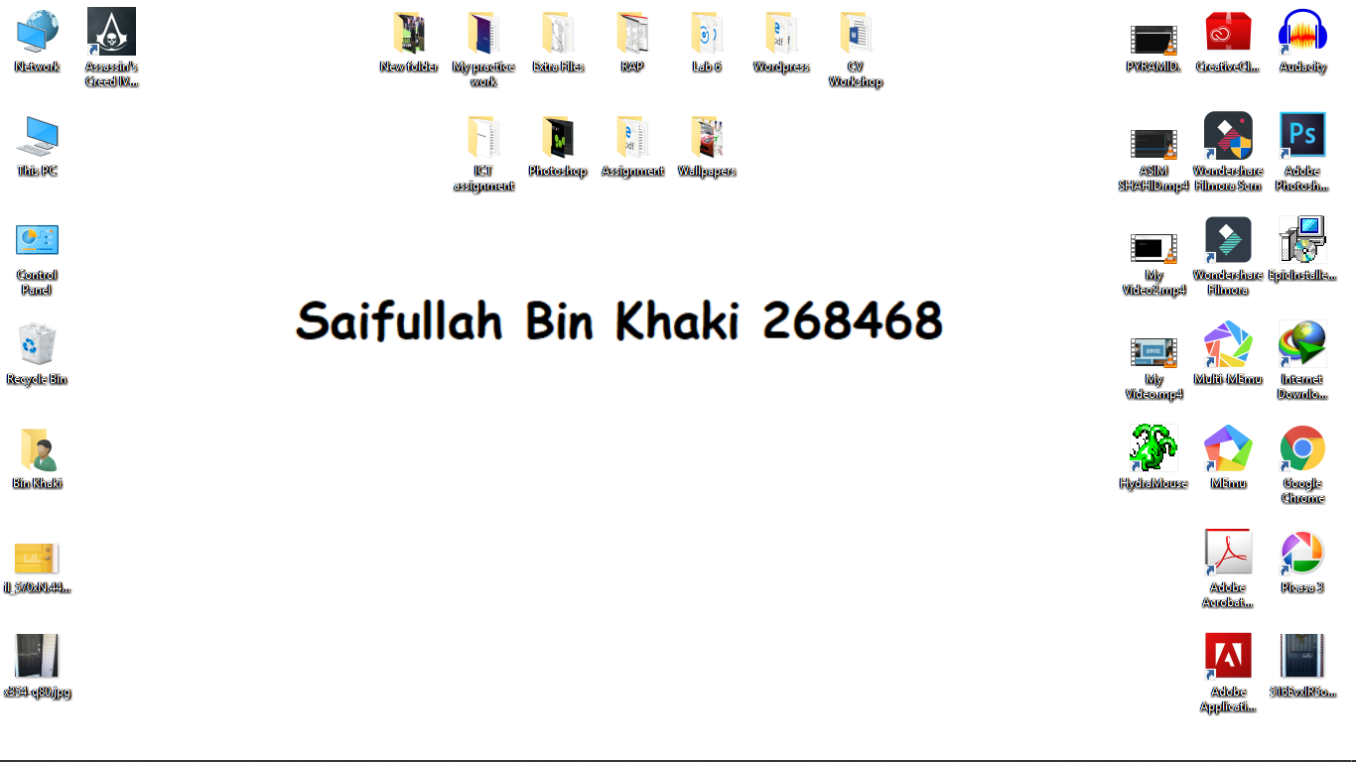

**“OPEN FREQUENTLY USED FOLDER”**

* Similarly in the HYDRA MOUSE window, first remove the **FORMER TRIGGER**.
* To make an access to frequently used folder, Click **RIGHT MOUSE BUTTON in INPUT TRIGGER**. Then, select **OPEN FOLDER…** from **ACTIONS**. A directory will open. Browse your frequently used folder. And then, click **SET TRIGGER/ACTION.**
* 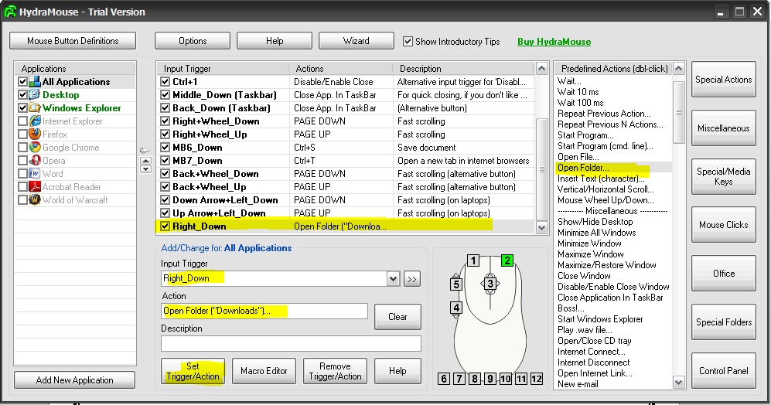A directory will appear, Select your recently used folder and click **OK**.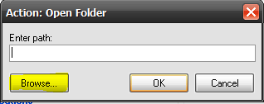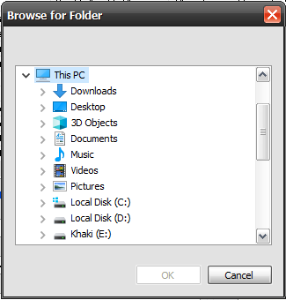
* Now take a benchmark, and on the desktop, click your RIGHT MOUSE BUTTON and observe the result. (I’ve made DOWNLOADS as my recently used folder).

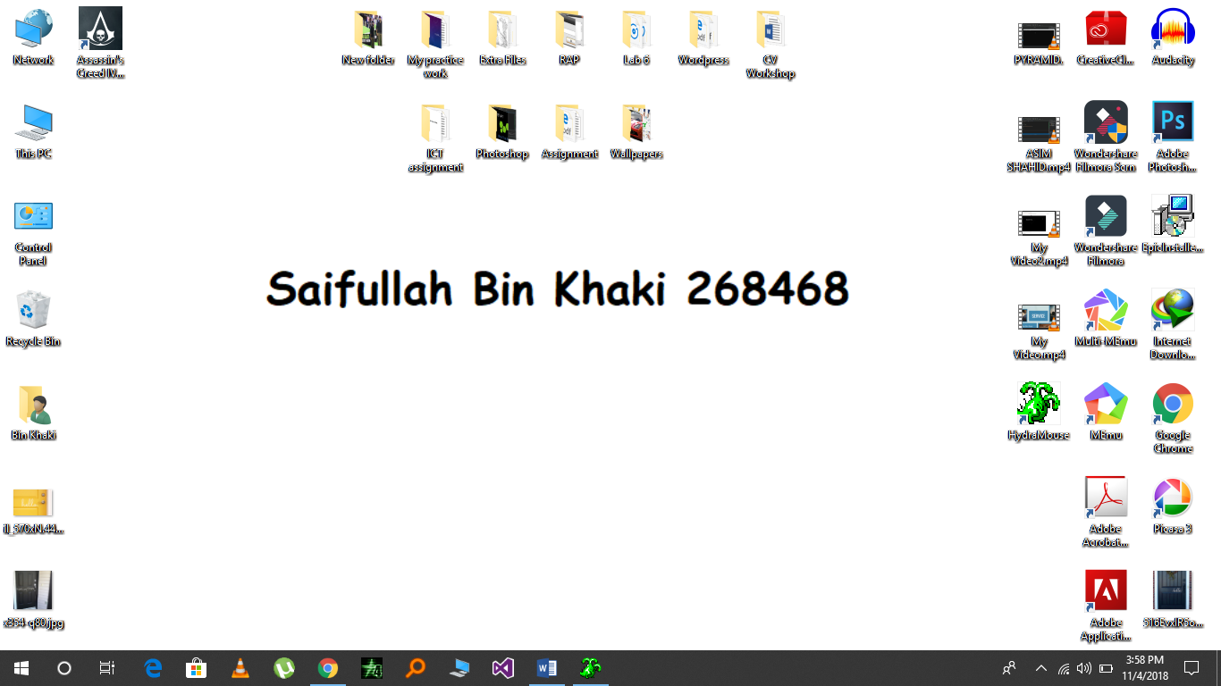

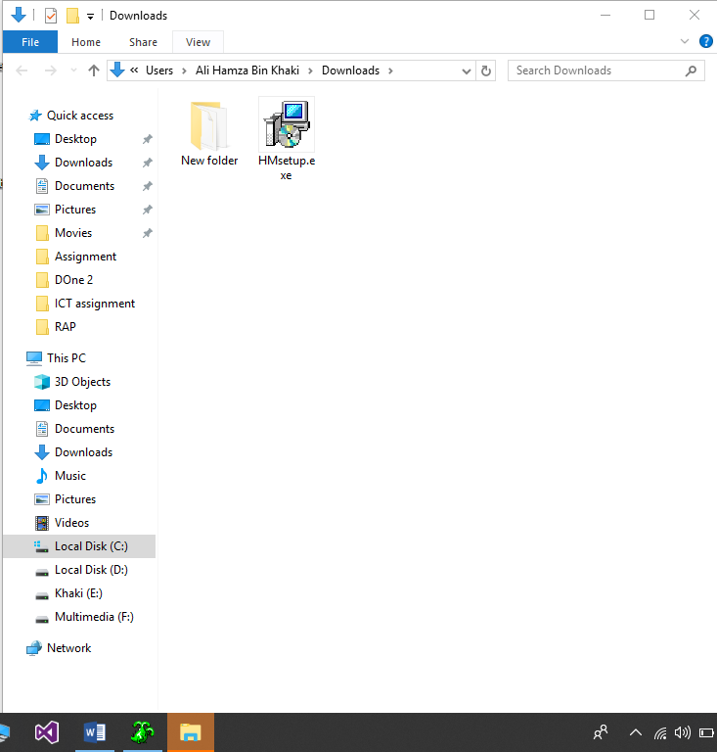

**“CLOSE AN APPLICATION”**

* Similarly in the HYDRA MOUSE window, first remove the FORMER TRIGGER.
* To close a window, Click **MIDDLE MOUSE BUTTON** in **INPUT TRIGGER**. Then, select **CLOSE WINDOW** from **ACTIONS**. And then, click **SET TRIGGER/ACTION.**

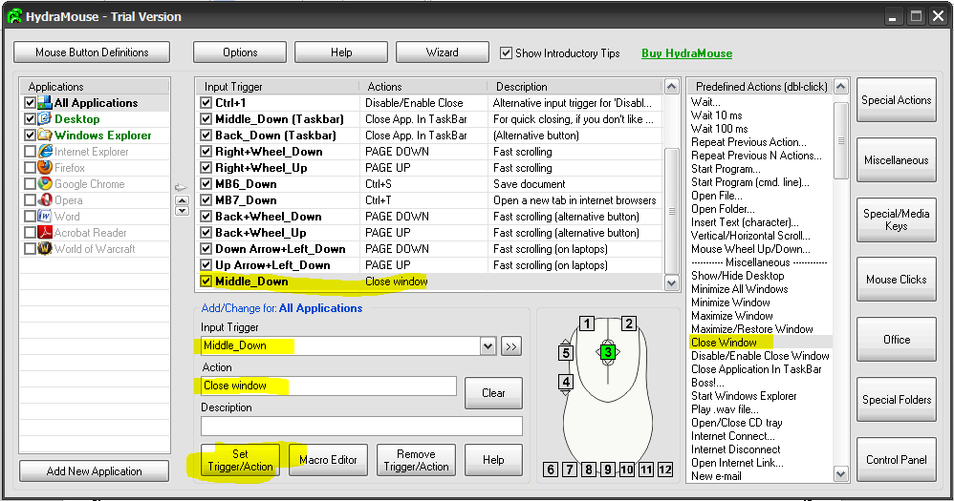

* Now take a benchmark, and on any window, click your **MIDDLE MOUSE BUTTON** and observe the result.

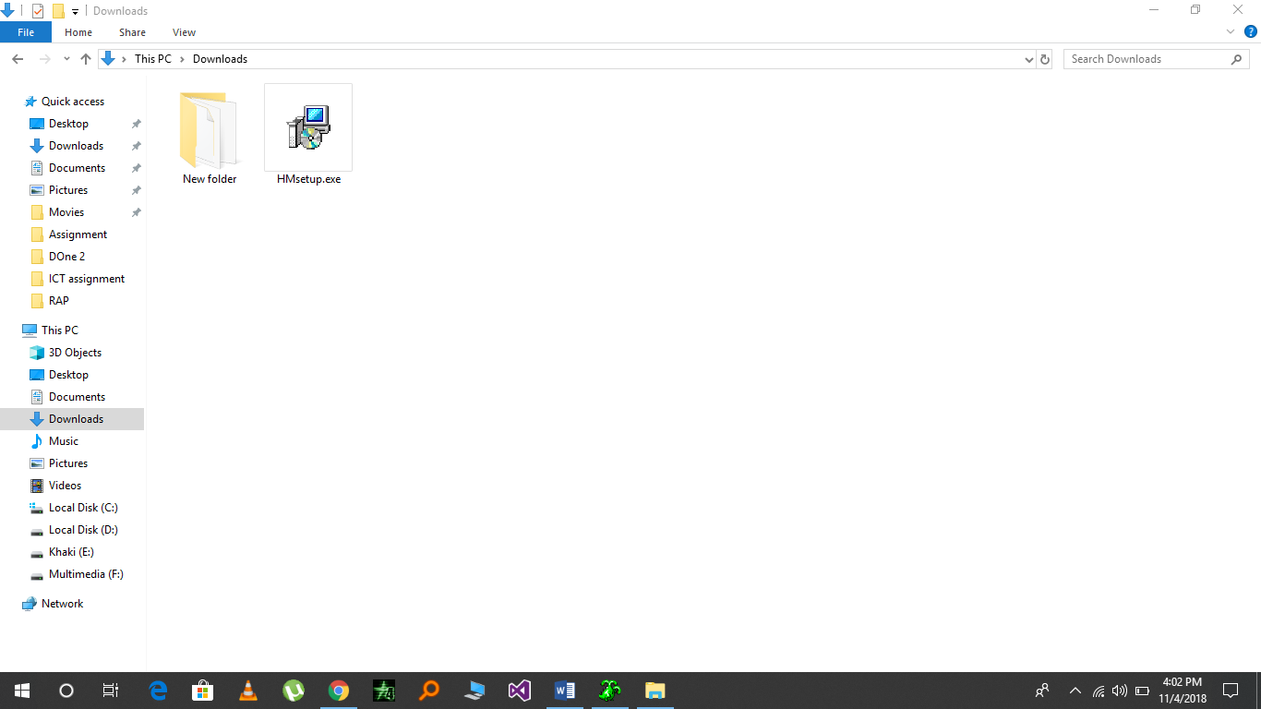



**“OPEN/CLOSE CD TRAY”**

* Similarly in the HYDRA MOUSE window, first remove the FORMER TRIGGER.
* Now, to open your CD tray in laptop or open/close in Desktop, change the function of your RIGHT MOUSE BUTTON to **OPEN/CLOSE CD TRAY.**

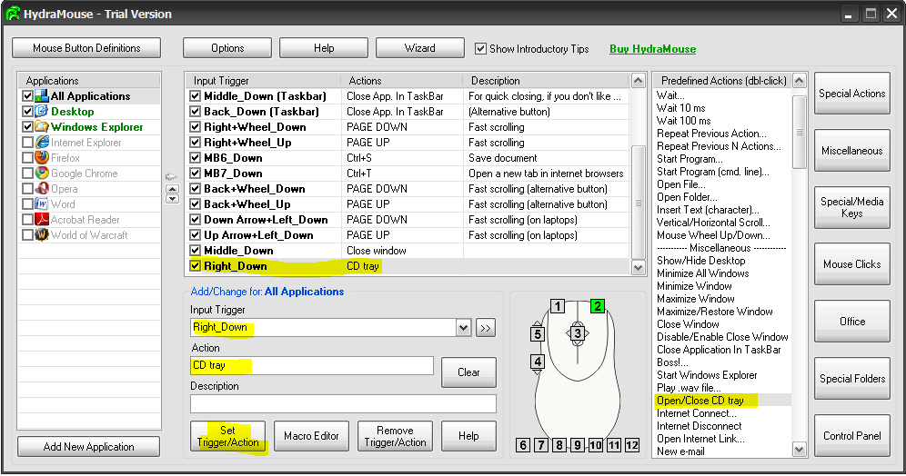

* Now take a benchmark, and on desktop, click your RIGHT MOUSE BUTTON and observe the result. Your CD tray will open (if close) and close (if open).

--------------------------------------------------------------------------------------------------